**Challenge 1**

**Question 1: How many letters is the encoded message shifted?**

**13**

**Challenge 1: Find the flag and input the answer**

The secret password is hidden under the bridge.

The flag is **ctfa{cipher_decipher}**

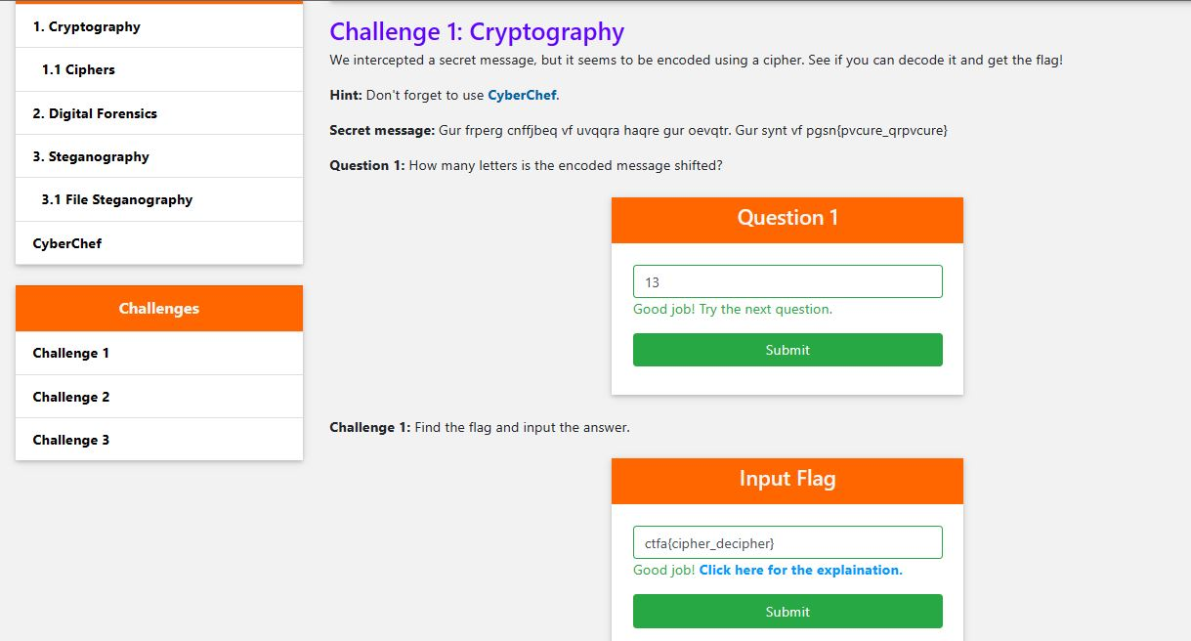

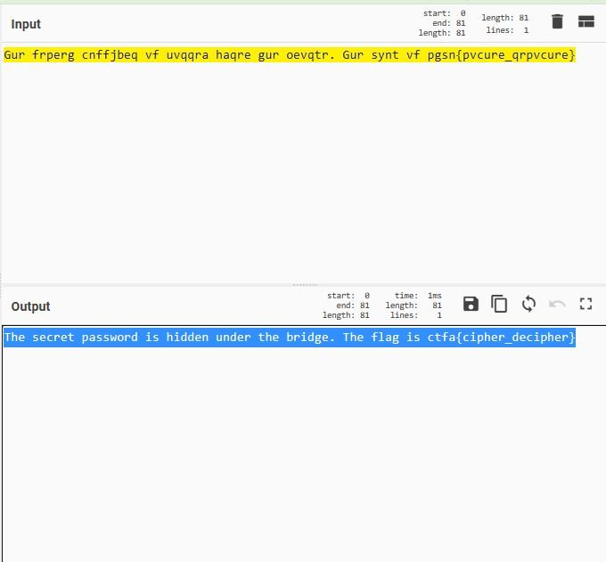

**Challenge 2**

**Question 1: What is the file signature for this file?**

**PNG**

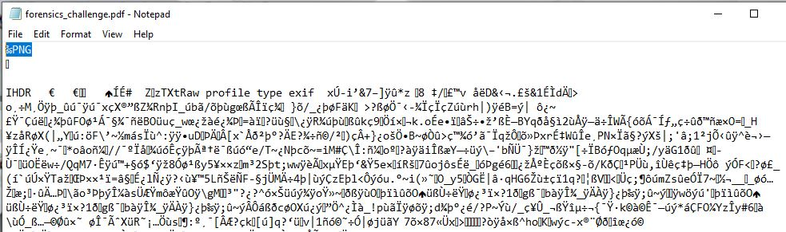

**Challenge 2: Find the flag and input the answer.**

**Flag: ctfa{extension_office}**

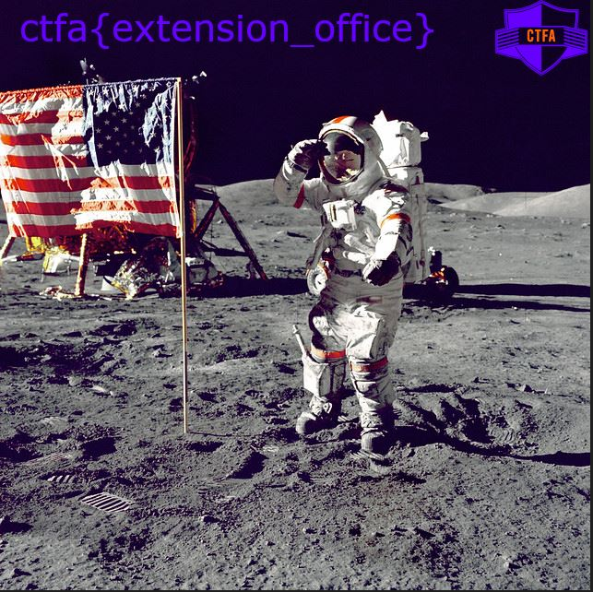

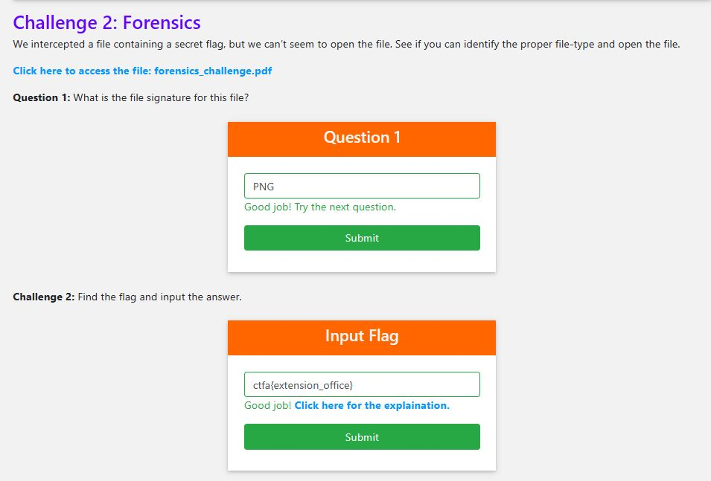

**Challenge 3**

**Challenge 3: Find the flag and input the answer.**

**Congratz! You found the flag! Here it is:**

**ctfa{Stegosaurus}**

